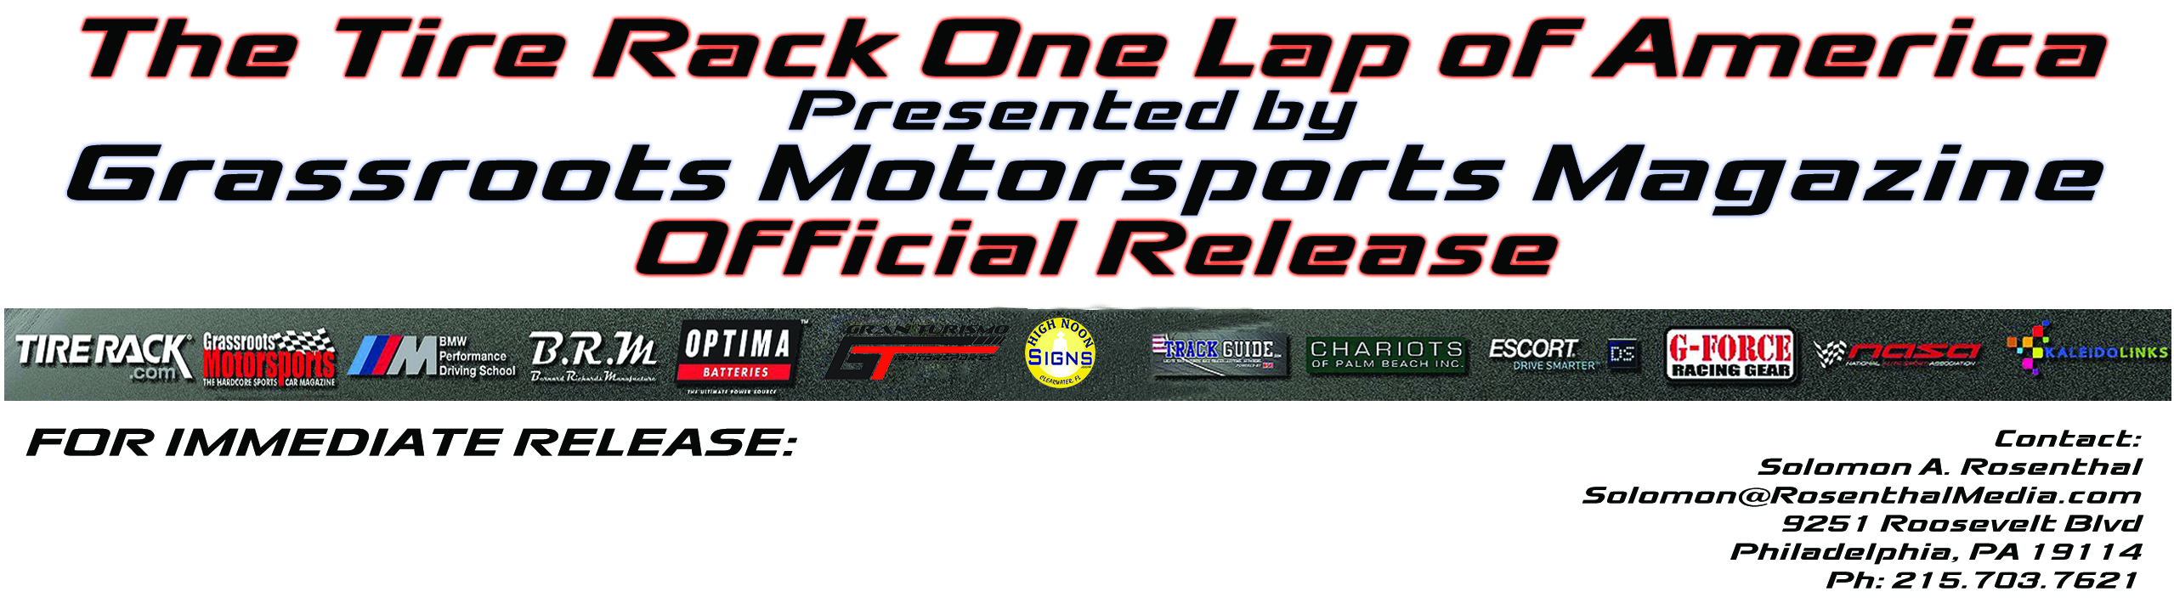

iRacing Partners with the Tire Rack One Lap of America Presented by Grassroots Motorsports Magazine.
Philadelphia, Pennsylvania, April 11, 2013 – The Tire Rack One Lap of America Presented by Grassroots Motorsports Magazine is proud to announce our latest partnership with iRacing, the world’s premier PC-based motorsports racing simulation. Due to the efforts of One Lapper David Wilks, iRacing has offered to get One Lappers ready for the 30th anniversary by offering all registered participants 3 months of free usage along with credits to purchase Daytona or Virginia International Raceway tracks. Additionally iRacing is offering class winners $100.00 in credit to purchase new tracks, cars or extend their memberships.
iRacing, the standard for online racing offers fun, easy, and inexpensive ways for race fans, sim racers and gamers alike to enjoy the thrill of the racetrack from the comfort of their home. iRacing is the ultimate place to go racing online. iRacing has it all; NASCAR, IndyCar, GRAND-AM, Aussie V-8 Supercars, Sports cars and Grand Prix racing,. All you need is a PC, a gaming wheel or game pad that simply plugs into the USB port of your computer and an Internet connection. iRacing organizes all of the racing for you with over 40 official series. You can also choose to host your own race or race in one of over 400 private leagues.

iRacing is a thrilling on-line experience that offers; The best on-line racing simulation and service in the world with brilliant features and functionality. Head-to-head racing competition - racing against real people. Open practice, qualifying, testing, time trialing competition. Constant free automatic updates and improvements to the service. Officially licensed cars that are engineered from the ground up in cooperation with real world race teams and using real-world physics. Officially-licensed, laser-scanned exact replicas of the world’s greatest racetracks. Officially-sanctioned racing organized by iRacing. An online community of racing enthusiasts over 40,000 strong. The ability to host your own private sessions, run your own tournaments or create your own private racing leagues.

The Tire Rack One Lap of America would like to welcome iRacing to the family and thank David Wilks for his efforts on behalf of all One Lappers.

